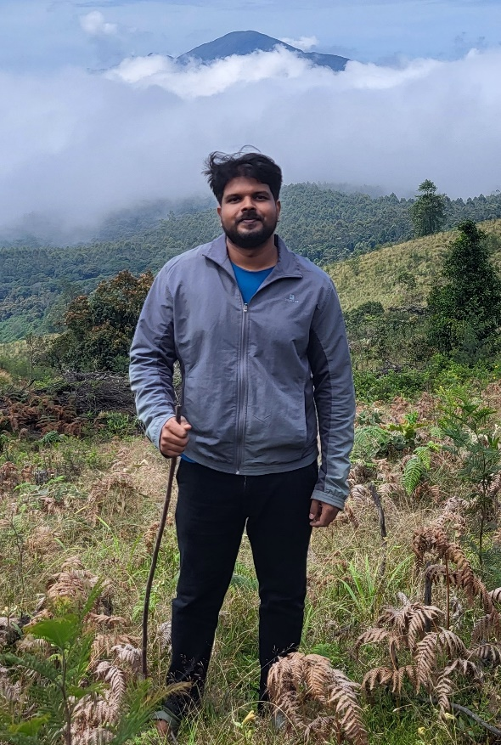

Experienced in ecology and conservation of Red listed trees of Southern Western Ghats, from Kerala Forest Research Institute. Now exploring plant community dynamics in fragmented evergreen forests. I also enjoy photography and identifying tree species.

Height: 172 cm